YEAR 11 PRACTICAL TEST - THURSDAY 24th August (Period 4)

In this test you will be required to identify four unknown substances.
Each substance is ionic and will be composed of a combination of the cations and anions below:

Possible cations | Possible anions
barium | carbonate
chromium(III) | chloride
copper(II) | hydroxide
iron(II) | iodide
lead(II) | nitrate
magnesium | phosphate
nickel(II) | sulfate
potassium
sodium
strontium

You will be provided with a solid sample of the substance AND a solution containing the dissolved salt.

SIDE BENCHES:
- Solid samples of each substance
- Metal loop and Bunsen burner (for flame tests)
- Watch glasses and hydrochloric acid (for carbonate tests)

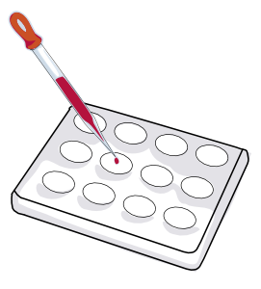
MAIN TABLES:
- Test tubes containing solutions of each substance
- Spotting tile (see diagram to right)
- Labelled solutions of:

  - Sodium chloride
  - Sodium sulfate
  - Sodium carbonate
  - Sodium nitrate
  - Sodium hydroxide
  - Sodium iodide
  - Copper(II) nitrate
  - Lead(II) nitrate
  - Potassium nitrate
  - Silver nitrate
  - Barium chloride
  - Potassium bromide
  - Magnesium sulfate
  - Cobalt(II) chloride

You will have 1 hour to determine the identity of your salts. You will be sharing equipment with another student, but you will be identifying different salts and therefore cannot work together.

You do not need to use all of the equipment that has been provided. You should decide which tests will be necessary to conduct your experiment.

This will be an open book test. You are encouraged to bring notes, including results from your flame test experiment.

